/**********************************************

**Workshop # 2**

**Course:** *JAC444 - Winter 2021*

**Last Name:** *Trokoz*

**First Name:** *Liubov*

**ID:** *139578199*

**Section:** *NBB*

*This assignment represents my own work in accordance with Seneca Academic Policy.*

*Signature*

**Date:** *13-02-2021*

**********************************************/

* 1. Detailed document includes screen shots of output:
* IncomeTax.java

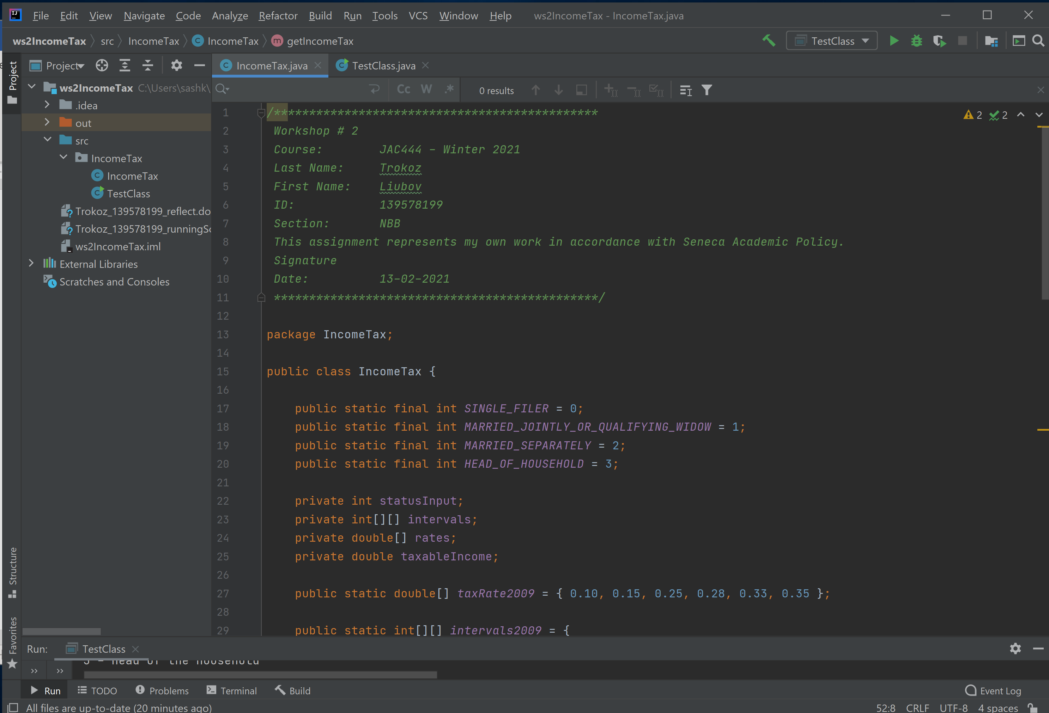

* TestClass.java

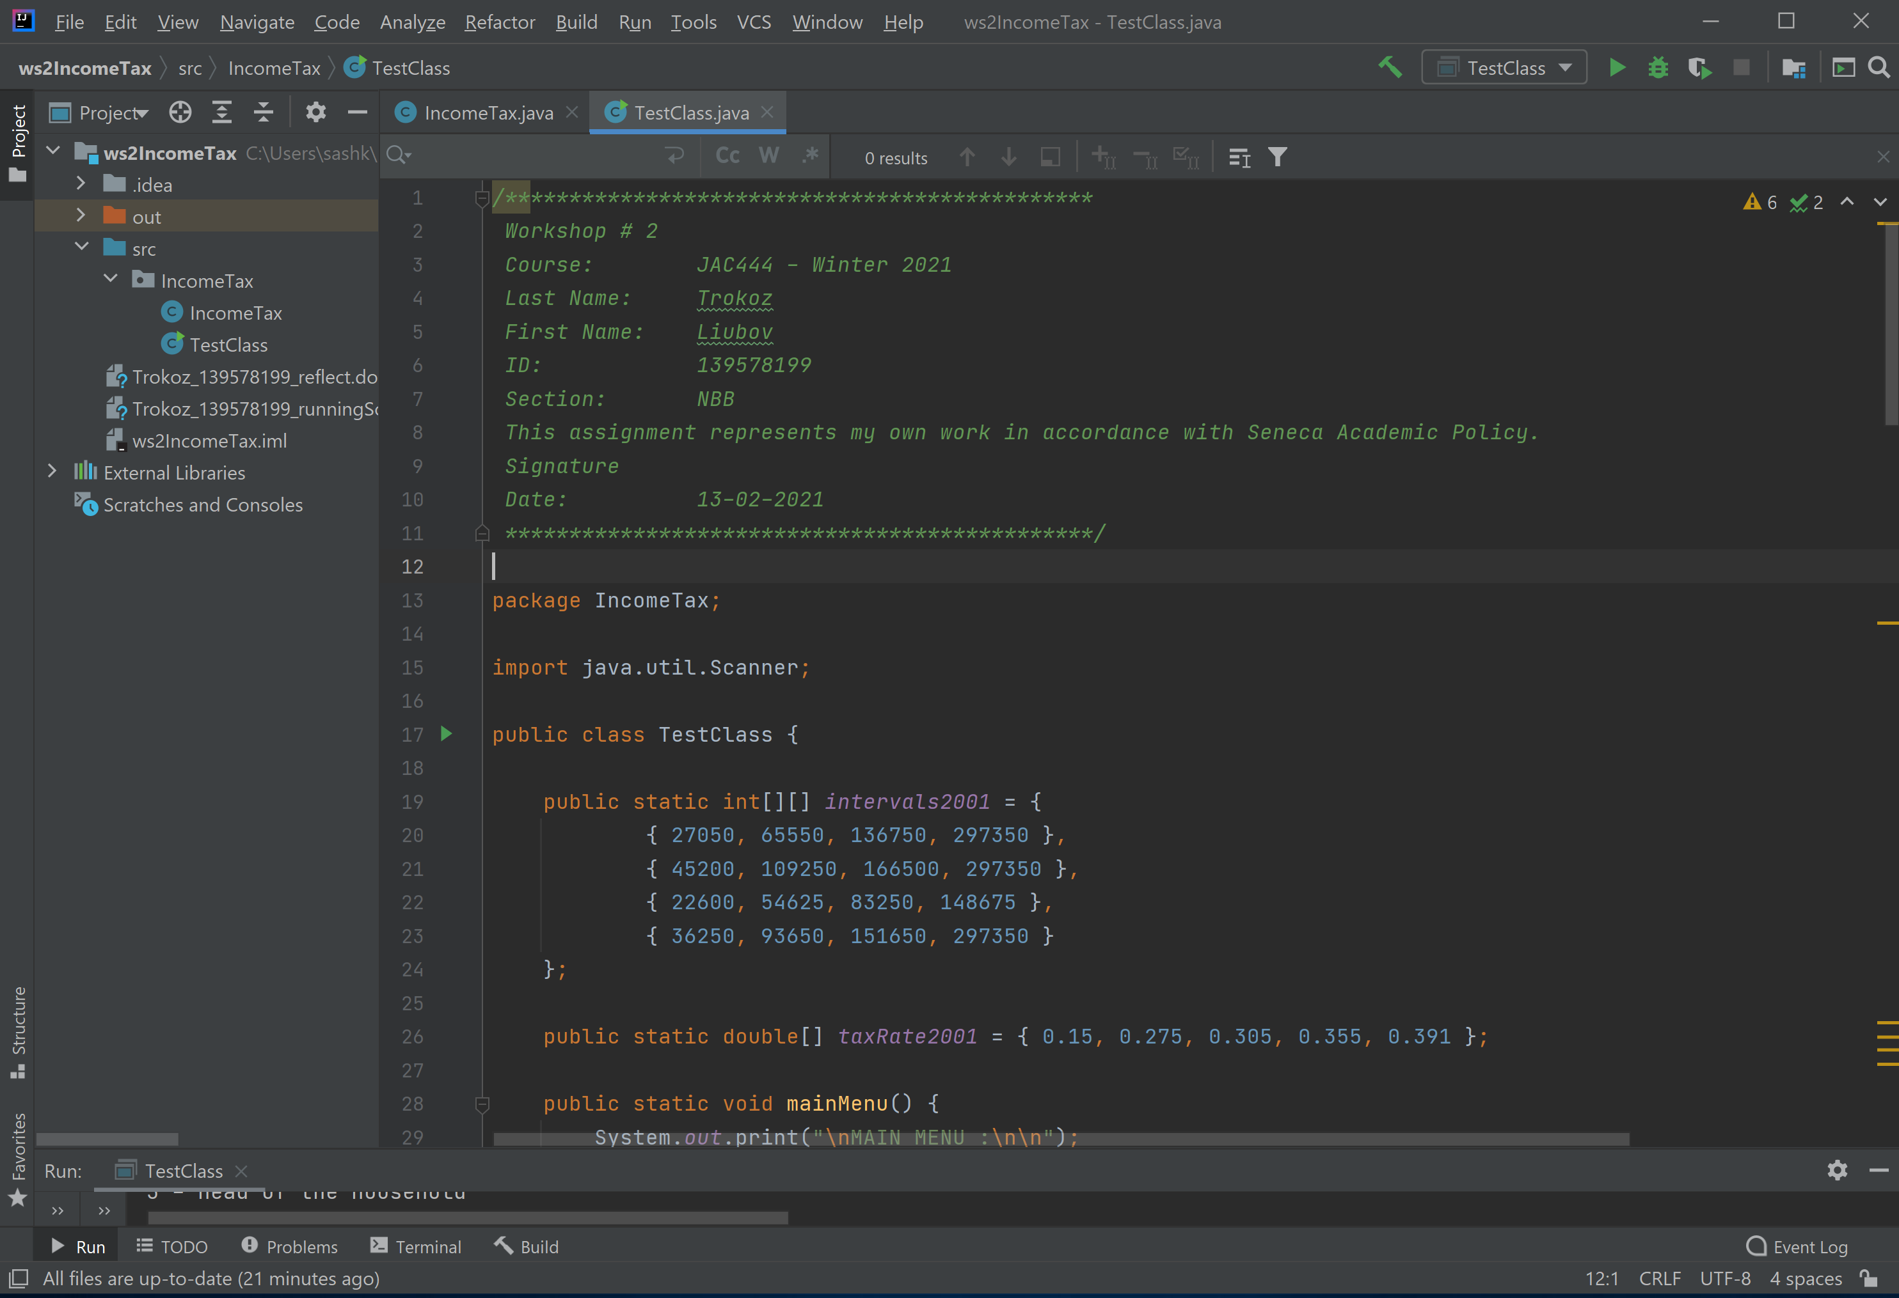

* Output for option 1

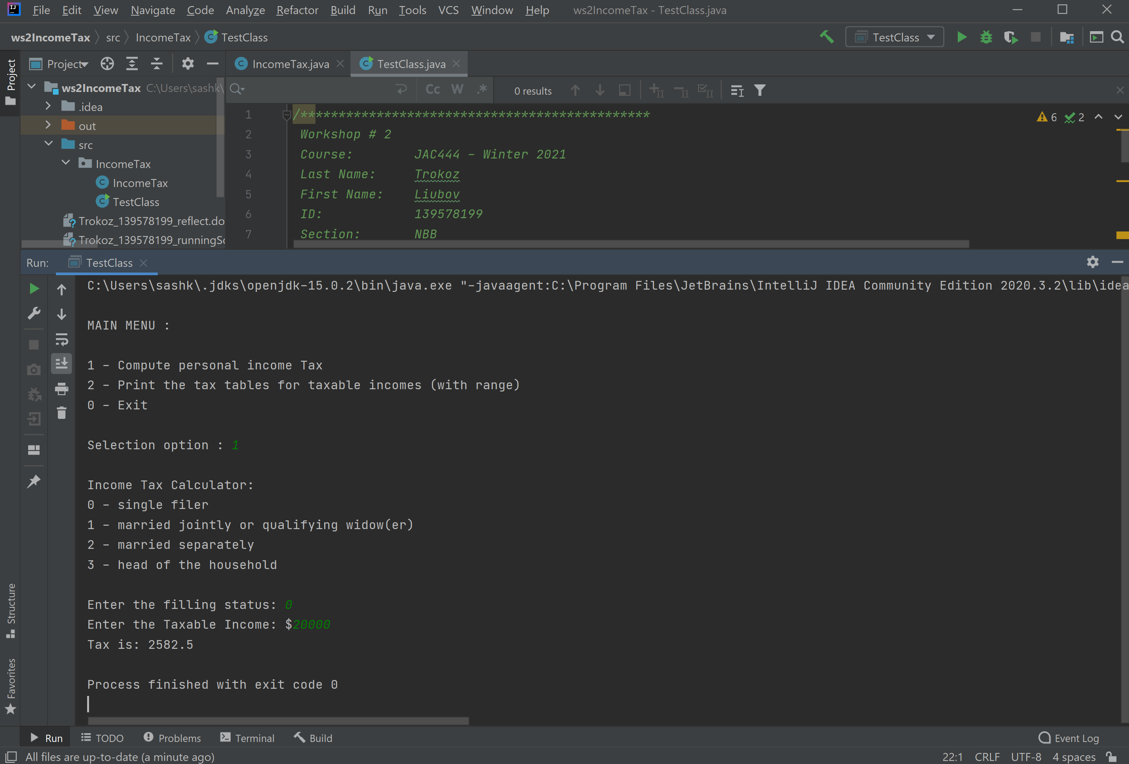

* Output for option 2

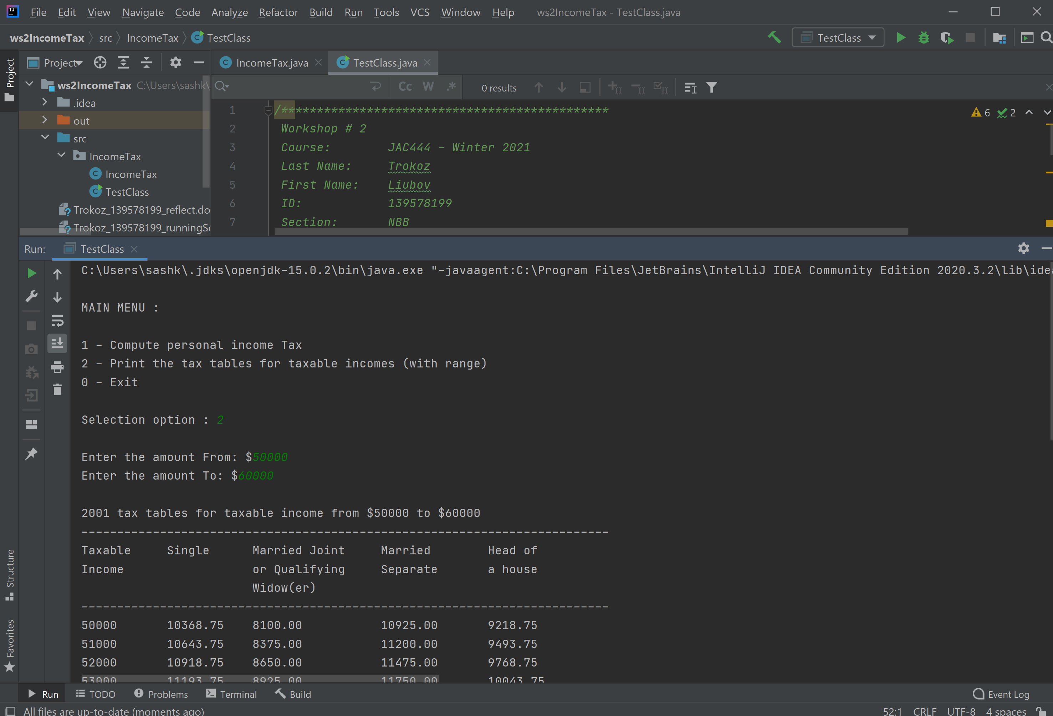

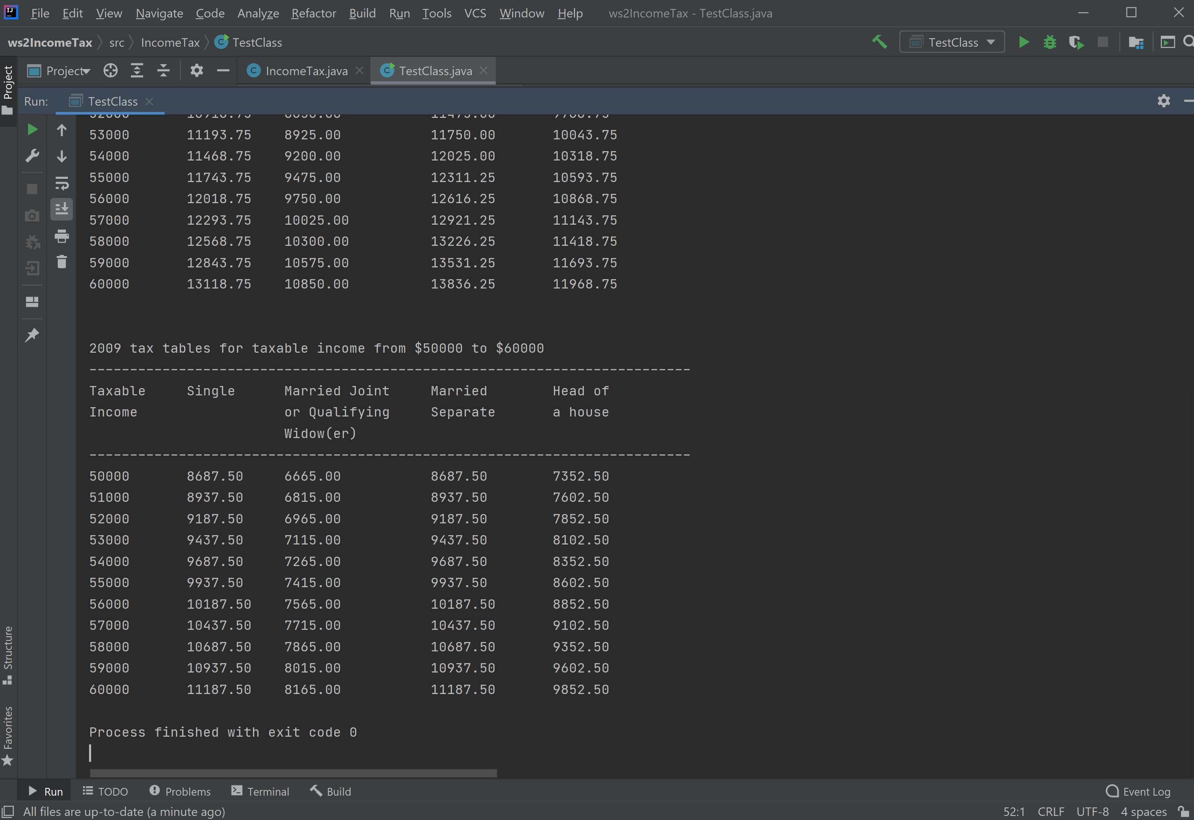

* Output for option 0 (Exit from program)

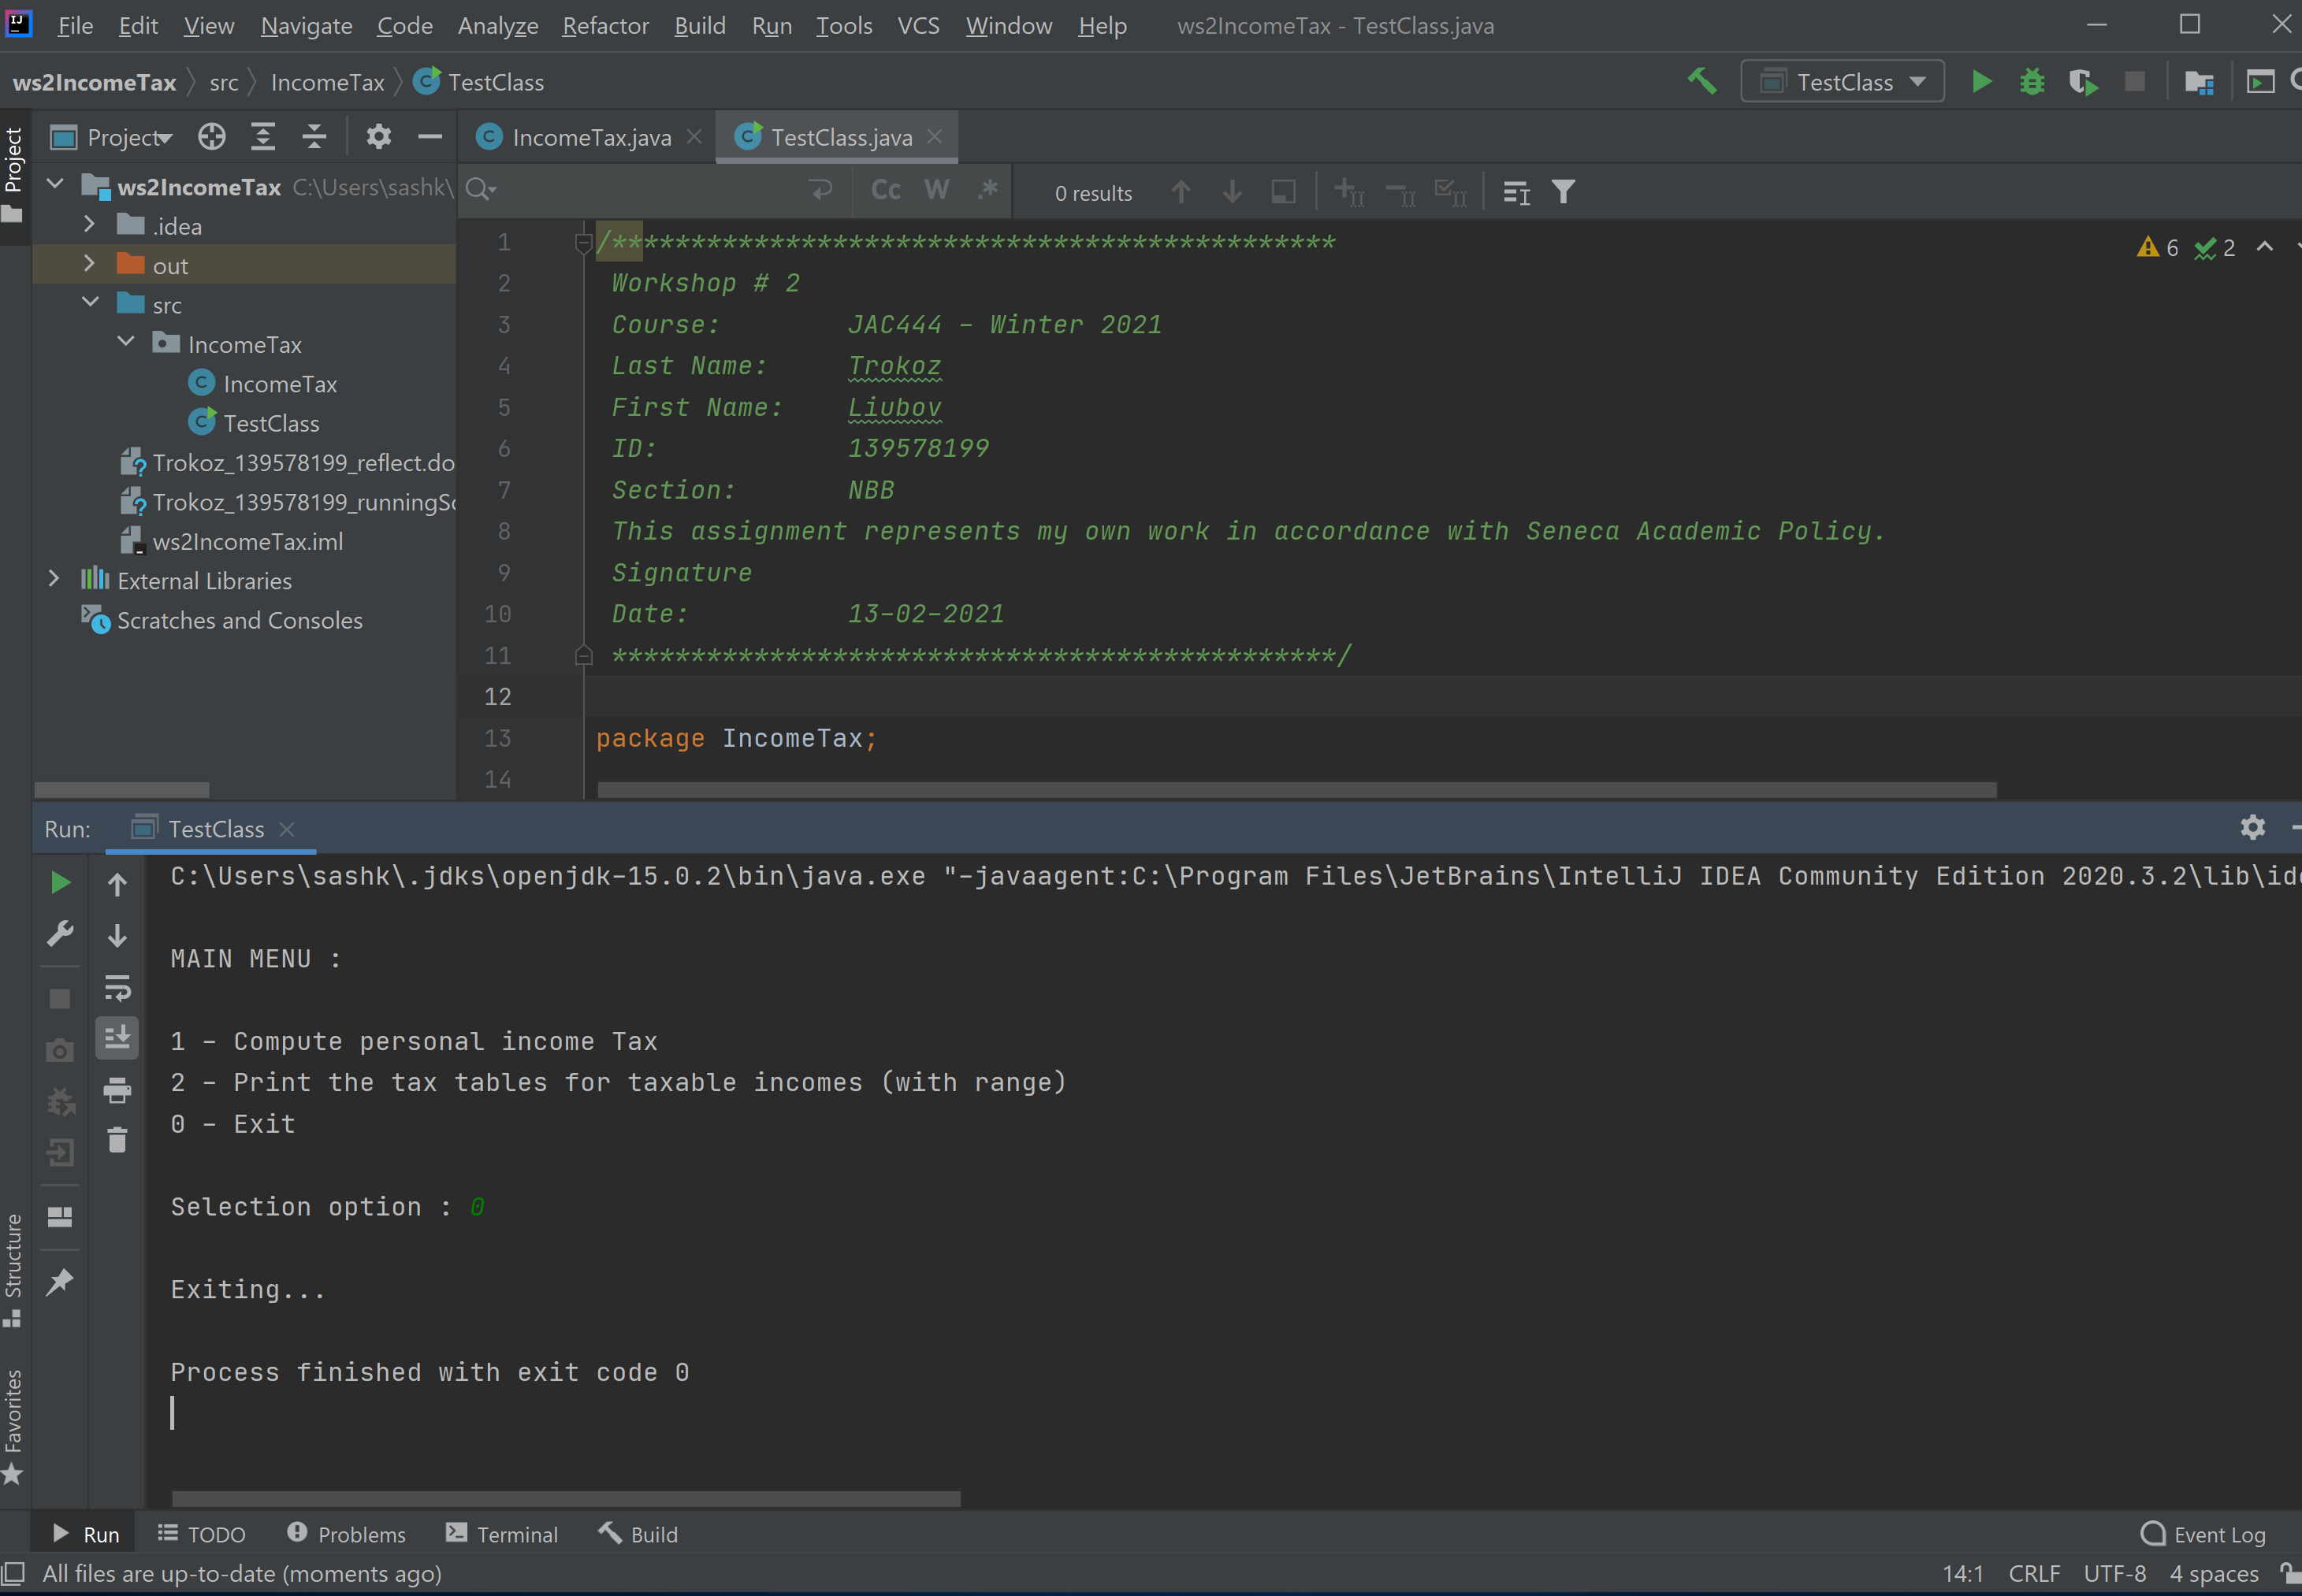

* Check user`s input and display warning message if user inputs a wrong number

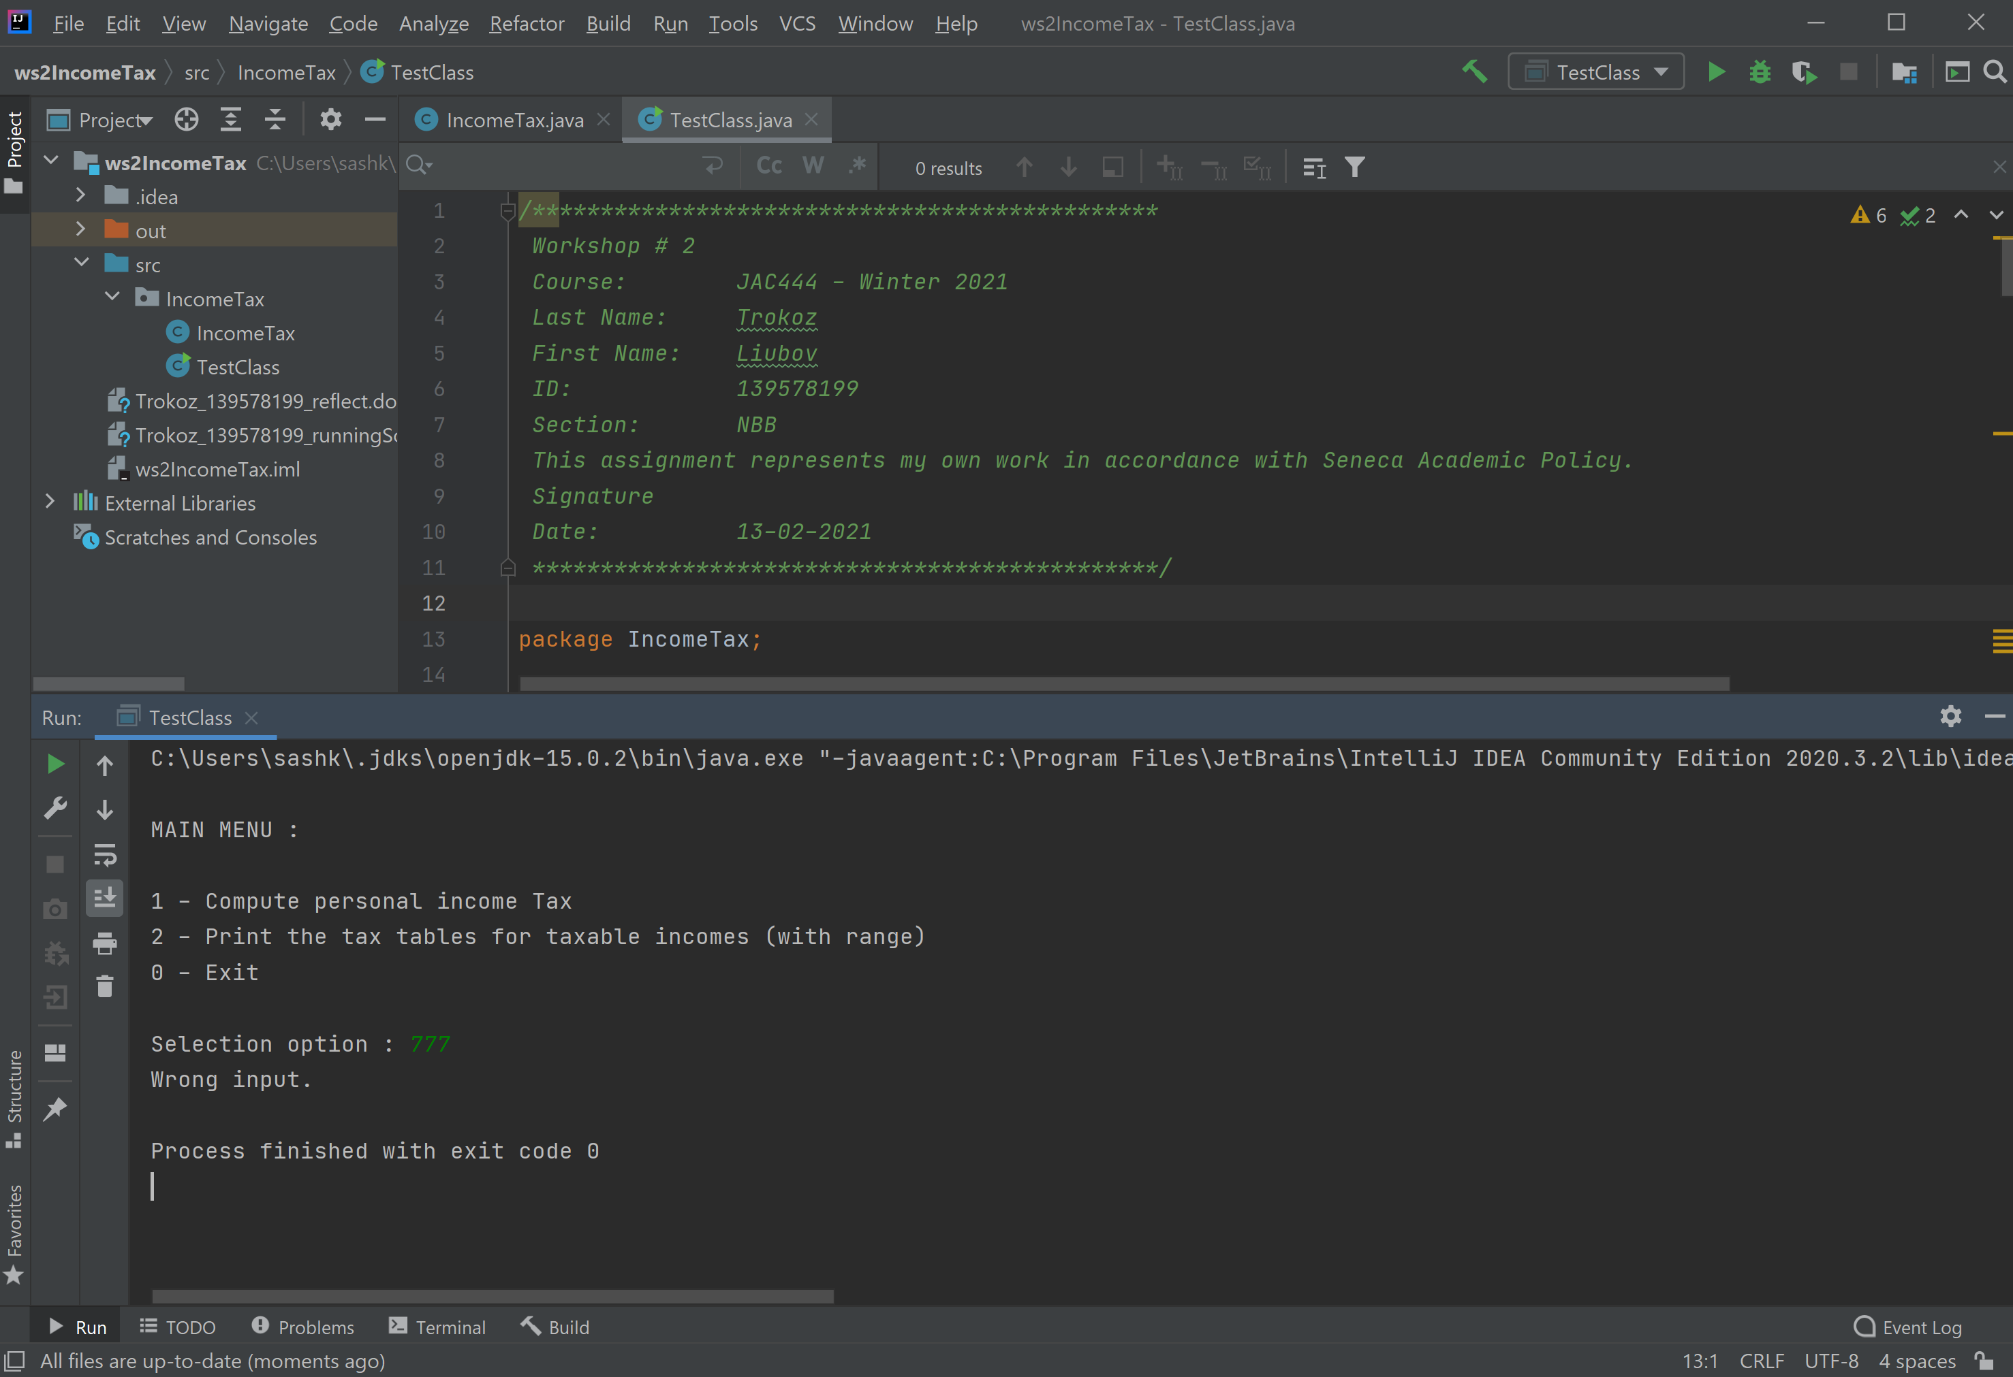

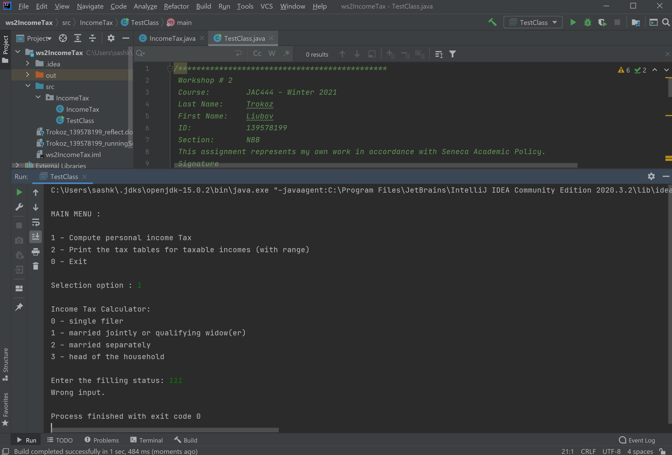

* Check user`s input for amount and display warning message if user inputs a too small income amount

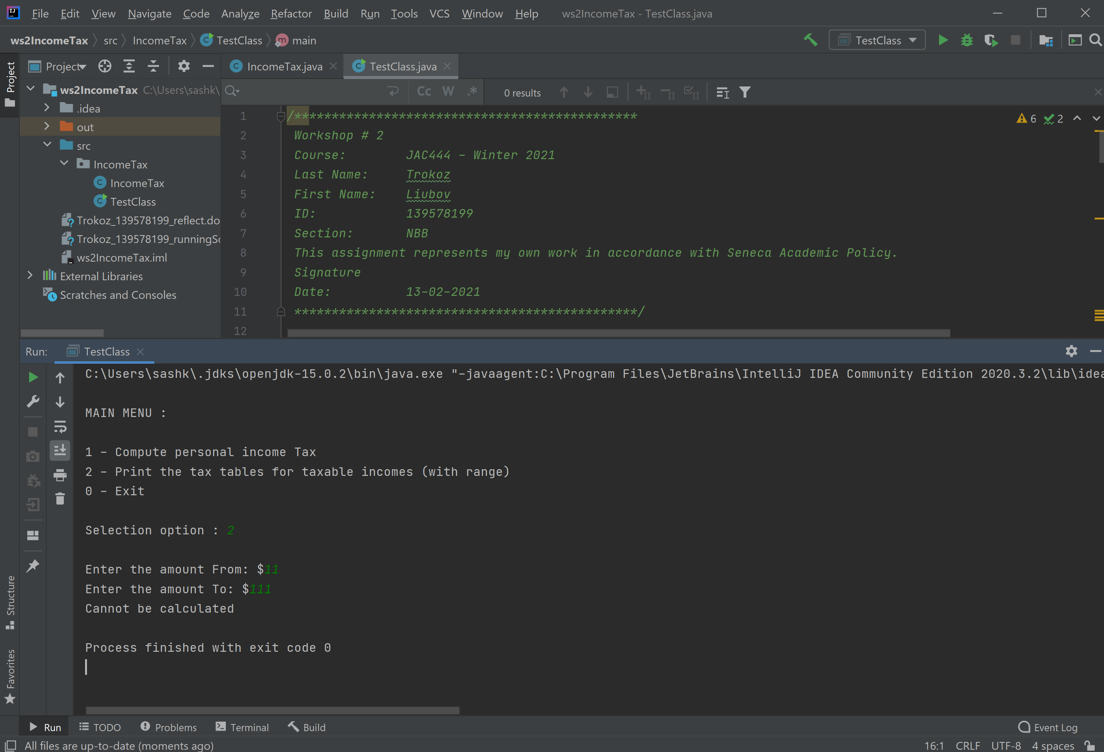

* Check user`s input for amount and display warning message if user inputs a too diapason for income amount

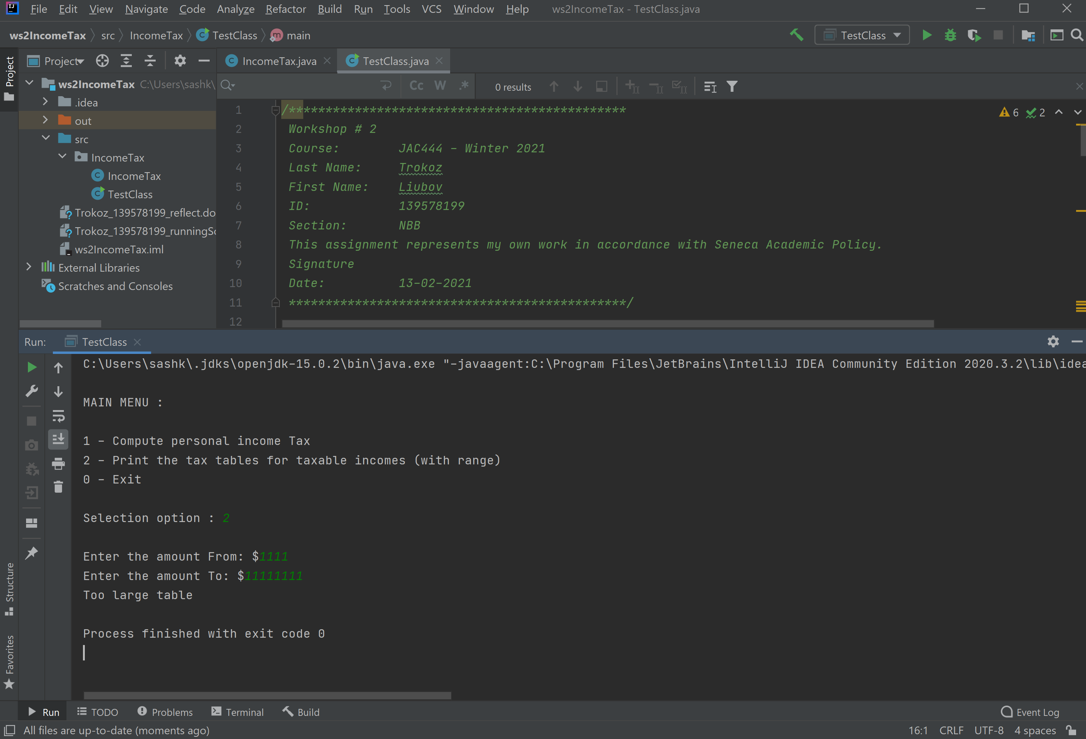

**The instructions on how to run code**

1. Open IntelliJ and create project

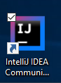

1. Open project

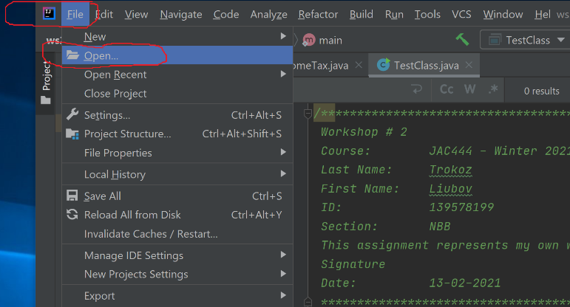

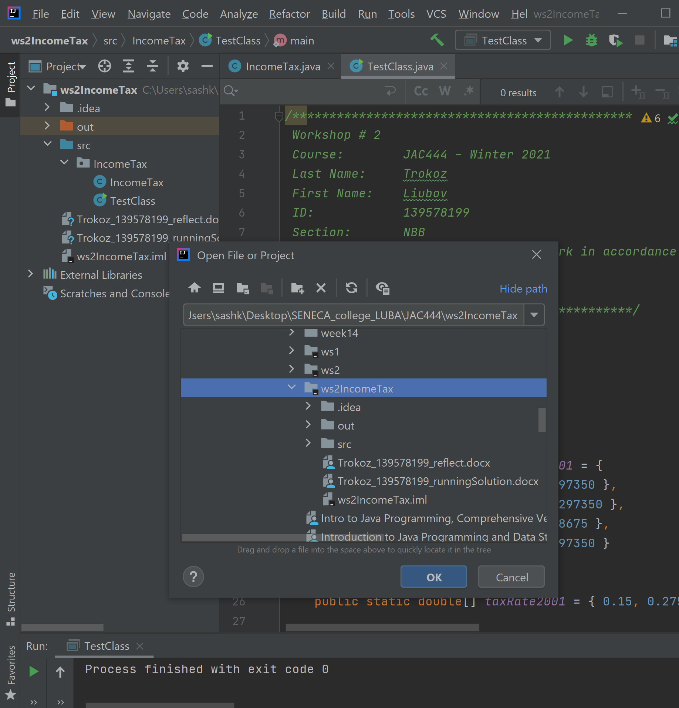

1. Run code – Shift + F10 (Microsoft)

